Civil war in Liberia

UNSC Resolution: | 1100
Date of adoption: | 27-Mar-1997
Operative paragraph: | 6
Demand number: | 1100,0611

Sarah-Myriam Martin-Brûlé

Wording of demand

cooperate with the peace process, including by respecting human rights and facilitating humanitarian activities and disarmament

List of addressees of the demand

National Patriotic Front of Liberia, Government of Liberia, Central Revolutionary Council of the National Patriotic Front of Liberia, Lola Defence Force, Liberian National Conference, Liberian Peace Council, United Liberation Movement of Liberia for Democracy - Krahn, United Liberation Movement of Liberia for Democracy - Mandingo

Short-term compliance

Description of the addressee(s)’ conduct

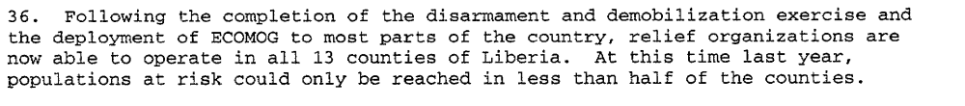
Twenty-third progress Report of the Secretary-General on the United Nations Observer Mission in Liberia, S/1997/478, 19 June 1997

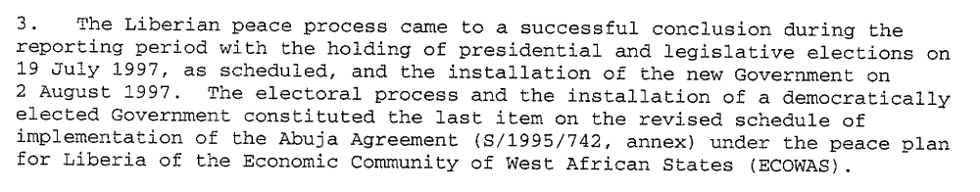
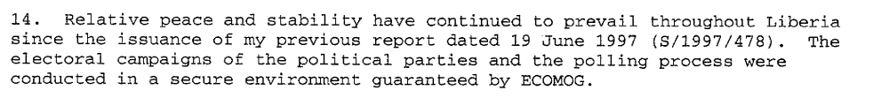
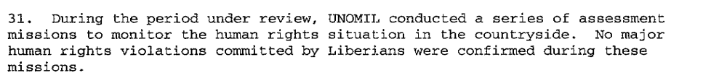
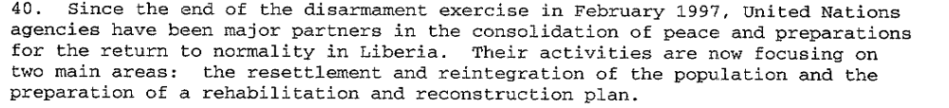
United Nations Security Council, Twenty-Fourth progress Report of the Secretary-General on the United Nations Observer Mission in Liberia, S/1997/643, 13 August 1997

Assessment

Short-term compliance
No or marginal compliance (1) | Medium low compliance (2) | X Medium high compliance (3) | Full or almost full compliance (4)

Considerations underlying the assessment

The demand addressees complied with those aspects of the demand which were or relatively high significance to the achievement of the objectives of the demand (significantly decreasing the number of human rights violation, and facilitating humanitarian activities and disarmament).

Medium-term compliance

Description of the addressee(s)’ conduct

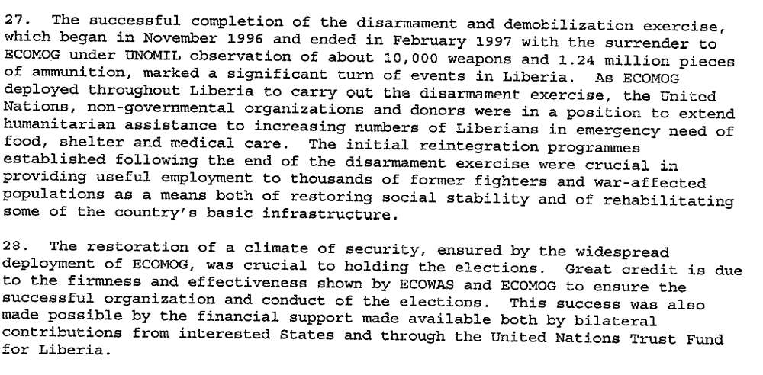
United Nations Security Council, Final Report of the Secretary-General on the United Nations Observer Mission in Liberia, S/1997/712, 12 September 1997

1998 18 September |  | President Taylor’s security forces (SWAP) attack and kill supporters of Roosevelt Johnson and Samuel K. Doe, both belonging to the ethnic Krahns, in Monrovia. More than 1,000 people are killed.

2000 July |  | LURD invades Liberia from Guinea.
2000 February |  | Anti-Taylor forces meet in Freetown, Sierra Leone and a declaration is produced creating the Liberians United for Reconciliation and Democracy (LURD) rebel group.
1999 September |  | Guinea accuses Liberian forces of entering its territory, attacking border villages.
1999 January |  | Ghana and Nigeria accuse Liberia of supporting the Sierra Leonean rebel group, the Revolutionary United Front (RUF).
IISS Armed Conflict Database

Assessment

Medium-term compliance
No or marginal compliance (1) | X Medium low compliance (2) | Medium high compliance (3) | Full or almost full compliance (4)

Considerations underlying the assessment

Within the two years following the adoption of the demand, the demand addressees complied with aspects of the demand which were of relatively low significance to the achievement of the objective f the demand. Violation of humanitarian law, re-armaments of fighters, resuming of hostilities testify of a medium low compliance in a long term peace process.

Depth of demand

Assessment

Level of depth of demand
Low depth of demand (1) | X Medium depth of demand (2) | High depth of demand (3)

Considerations underlying the assessment

Mistrust persisted between the warring parties. Hence disarmament represented a significant risk for each demand addressees.
“George Boley, Alhaji Kromah, and civilian politicians continued to insist on total disarmament before elections. (Adebjao 2002: 221)
Adebajo, Adekeye. 2002. Liberia’s Civil war: Nigeria, ECOMOG and Regional Security in West Africa. A project for the International Peace Academy. Lynne Rienner Publisher

Level of confidence about coding decisions

Level of confidence about coding decision
Extremely high | High | X Moderate

Comments to IPI (if any)

